Ladybird survey

Key learning points
- Surveys are types of scientific test used to gather information about a place or a population.
- Recording detailed notes is important for determining if a test is fair.

Key words
Population – A group of things.
Survey – A scientific test used to gather information about a place or a population.
Data – Pieces of information. Singular – ‘datum’.
Fair test – A type of scientific investigation where the effect of changing one factor can be separated from other changes. Usually, scientists try to do this by changing one thing and seeing what happens. Sometimes they will do the same experiment many times, changing something different each time.
Note: When studying nature, it’s often not possible to only change one thing. Because of this, scientists try to take detailed notes. In the included case study, scientists tried to collect on days with similar weather, but they could not control the weather so they recorded the air temperature each time so they could check later if that had an effect on their results.

What to do
Part 1: Decide how to do your survey
(Feel free to use the included pre-made survey sheet if you would like to skip this section.)
- Review information about ladybirds.
- Students think about what might affect how many ladybirds they find.
- Start making your survey sheet by deciding what needs to be recorded.
- Go out to the area you will be surveying and identify places you want to survey.
- Revisit your survey sheets and make any changes or additions based on what was observed outside.
- Groups share what they think they should record.
- Identify what can be recorded as a class, and what each group needs to record.
Date, time, weather and similar data could be recorded by the research leader (teacher) because all the groups are going to be surveying at the same time.
Location, and ladybird types and numbers need to be recorded by each group because they will be surveying in different places.

Part 2: Do your survey
- Point out the boundaries of the habitat where you will be hunting.
- Introduce the equipment and how to use it safely.
- Collect ladybirds using your agreed method, and record notes as necessary.
- Record the numbers and types of ladybird which have been found.
- Gently return the animals near where you found them. On the ground is okay. They will climb or fly back home.

Example survey sheet
Researchers: | Date:
Describe survey location: | Temperature:  Weather:

Species | Tally
Other wildlife or observations:

Sharing results

Key learning points
- Recording detailed notes is important for determining if a test is fair.
- When reporting on findings it is important to choose a way of displaying data which clearly shows the answer to your question.

Key words
Population – A group of things.
Survey – A scientific test used to gather information about a place or a population.
Fair test – A type of scientific investigation where the effect of changing one thing can be separated from others. Usually scientists try to do this by only changing one thing.
Note: When studying nature it is often not possible to only change one thing. Because of this, scientists try to take thorough notes. In the included case study, scientists tried to collect on days with similar weather. They also recorded what plants they collected from so they could check if that affected their data.
Data – Pieces of information. Singular – ‘datum’.

What to do
- Go through the case study to look at how the scientists presented their data in different ways.
- Decide what information is needed to present the answer to your research question.
- Students construct graphs to present their data.

Alternatively
Students could upload their survey results to iRecord (https://irecord.org.uk/).
The goal of iRecord is to make it easier for wildlife sightings to be collated, checked by experts and made available to support research and decision-making at local and national levels. iRecord can be used to share your sightings with the recording community, explore dynamic maps and graphs of your data and make a real contribution to science and conservation. It is operated by the Biological Records Centre (BRC) as part of the work of the UK Centre for Ecology & Hydrology (UKCEH).

What to do
- Register an account (no cost)
- Use the specific ladybird Species Group Form.
- Attach any photos you’ve taken of the ladybirds to help the record centre verify your results.
- Fill in the Where was it? form.

Ladybird Species group form
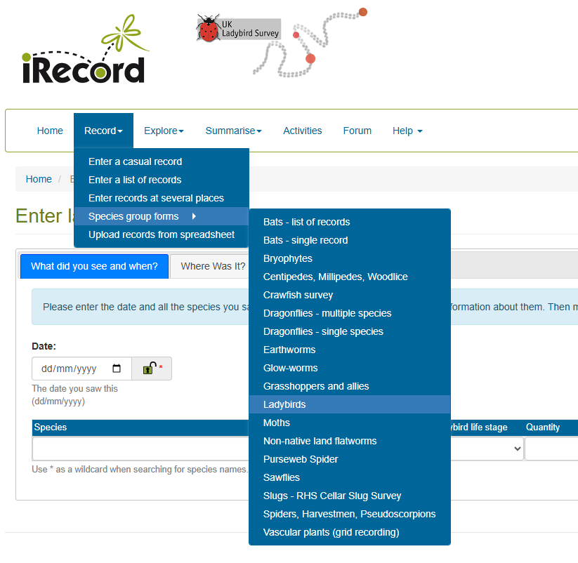

Where was it? form
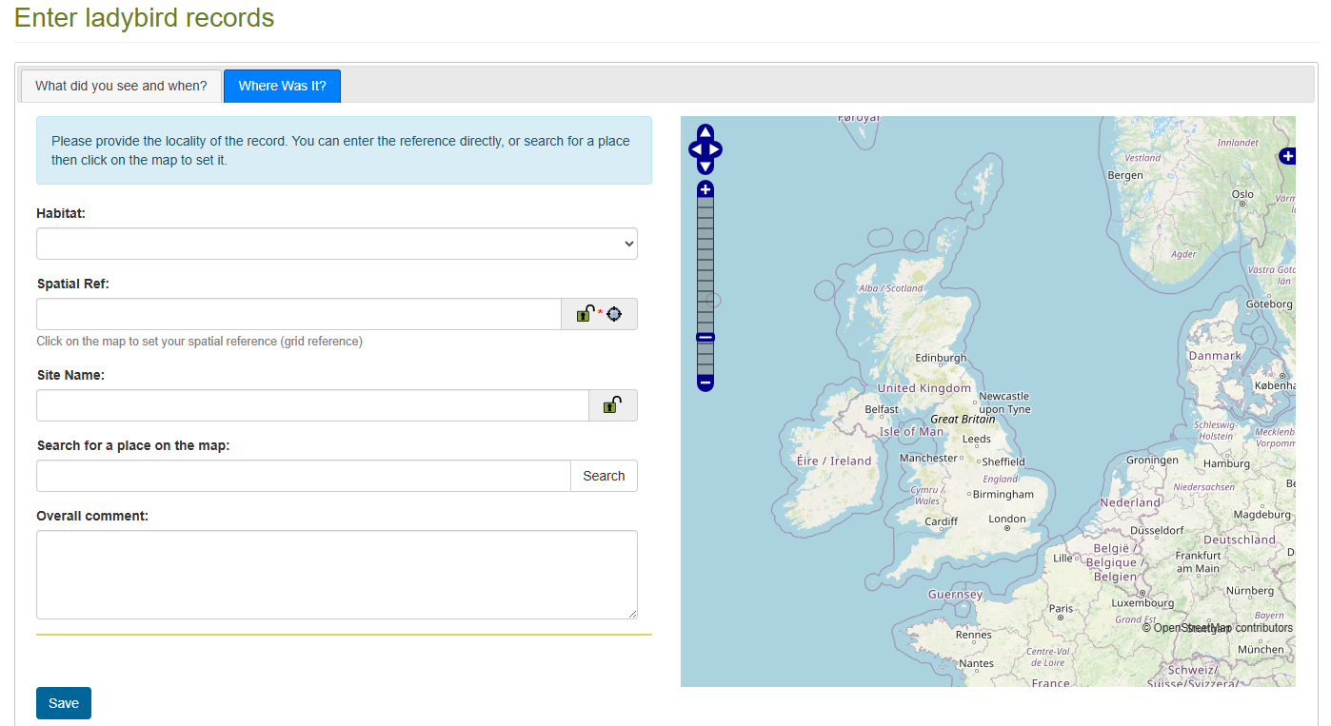
You can search for your post code or zoom in on the map and click where you did your survey.
Notes about plants or weather can be included in Overall comment:

